**Chapter 1**

**INTRODUCTION**

With the evolution of technology, customers are becoming more inclined towards online-based searches, and the offline market is shrinking. The local offline search market faces challenges and low acceptance in corporate cultures, lack of awareness, paper wastage, language barriers, and insufficient information. The Digital Advertise (stylized as D-Ads) is a web application provides local search for different services online. To simplify the day to day activities of the buyers and sellers, D-Ads delivers a local search for a structured database of local business listings. D-Ads makes it easy to locate and find detailed information about a particular Product/Service like Car Service Center, Electronic shops, Salon shop, Mobile Shops, Renting House or Flats, Cloths shops and along with this information we can provide discount offers if any. D-Ads is the Local Search Engine that provides comprehensive updated information of all the Business to Business and Business to customer products and services.

D-Ads helps the buyer to display advertising of their product/services on the platform and sellers to get in touch with each other, and it will act as an intermediary between the buyer and the Seller. D-Ads Platform will only have verified and trusted sellers with guaranteed assurance from customer support.

**1.1Objective**

The main objective of the project is to allow verified business data available and detailed information about the Product/Services in one place, so the user needs not to worry about the other resources to find the required information such as finding a car service center or mobile repair shop nearby.

**Chapter 2**

**LITERATURE SURVEY**

**2.1 Existing system:**

As of now, there are no local platforms available for this kind of service to collaborate with the buyers and sellers together. When a client needs some services or needs to find the information about the particular hotel some product on the local market, he/she has to survey the local shops/services and fulfill the requirement that is time-consuming and sometimes takes the wrong decision. All the product/service details are not available online at this time.

If a user needs information about the Driving School, then the customer needs software that helps to get information about the requested Services.

**Disadvantages of Existing system**

* Time-consuming.
* Clients cannot get all the information in a short time.
* Clients have to travel to get details about the Product/services.
* No Records are available online.

**2.2 Proposed system**

To overcome the disadvantages of the existing we are developing a new computerized system called **D-Ads** (Digital Advertise)

With the help of this software, we will reduce tasks deployed for information collection to a large extent and promote the buyers online also can reduce client efforts and time during the searching of products/services. It makes available on the local shops/services online.

**Advantages of the proposed system**

* Customers can get full information about Business.
* Sellers can advertise their Business to the Buyers.
* Buyers can rate the services provided by sellers (To verify the sellers and their services).
* All the records are stored in a secure database.
* If somehow data may be lost, then we can restore it quickly.
* We can get all the information in detail at our fingertips.

**2.2.1 System Architecture**

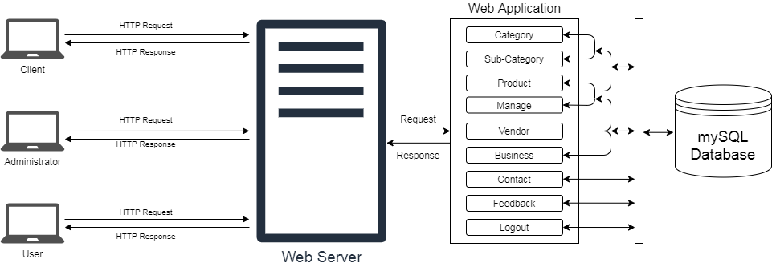

Figure 1 System Architecture

A system architecture is the conceptual model that defines the structure, behavior, and more views of a system. D-Ads System architecture is shown in (fig. 1) includes web-browser client, MySQL Database Server and Web Server, Application server contains processing modules for data processing.

Web-Browser client - provides access to D-Ads system can be provided via the web-interface, user can use any modern web browser (including Microsoft Internet Explorer, Google Chrome, mozilla firefox) to login to the system and use it. Web-Server that comes with cloud linux operating system used to install application and database software for hosting solution that utilizes server system.The View of D-Ads system – in this application provides us the possibility of complete control over the management of the Product/Servers such as Add, edit and delete information for D-Ads System.

MySQL Database – to guarantee scalability and fault- tolerance, data stored in MySQL Database, and the load balancer works in a completely transparent way. The web-interface for the D-Ads system has been developed using the Bootstrap library. The interface of the developed web-forms is provided on the (see Chapter. 6). Architecture of D-Ads System.

**2.3 Feasibility study**

A feasibility study is an analysis used to measure the ability expectation to complete a project successfully, including all relevant factors that affect it, such as operational, technical, and economical. A feasibility study is used to determine the positive and negative outcomes of the project.

**2.3.1 Operational feasibility**

Vendors are ready to use this application software for managing their information, and it is acceptable by the administration as well to make available all the information in one place.

**2.3.2 Technical feasibility**

* + Several issues we have to consider while doing technical analysis.
  + Understand the different technologies involved in the proposed system.
  + Before commencing the project, we have to be very clear about what are the technologies that are to be required for the development of the new system.
  + Find out whether the organization currently processes the required technologies.
  + For this project, we have used Dreamweaver as a front-end editor and MySQL as a backend.

**2.3.3 Economical feasibility**

In this study, The cost of the proposed system is less as compared to the maintenance cost in the existing system in which more cost involved in maintenance. The system also reduces the administrative and other users to do various jobs that available software can do. So, this system is economically feasible.

**Chapter 3**

**SOFTWARE REQUIREMENT SPECIFICATION**

**3.1 Introduction**

This document describes the software requirements, hardware requirements, purpose, and the nature of the software which are developing.

**3.1.1 Purpose**

Those principle reasons this project may be on mechanizing the existing system of information in which data will get from the different data sources to reduce the time of data collection, the proposed system came into existence.

**3.1.2 Scope**

To provide fast, free, reliable, and comprehensive information to our users, connect buyers to sellers, and provide quality. Online Advertising Agency System is designed to provide general information about the advertisement. The scope of the system definition the system on which the system works. The system has a full, but out of the content, the system is not working. All types of users use this system. Users can register online by providing their personal information with valid email and phone and get it verified by the system. Users can search for the product or services like Car showroom or a saloon or any other govt. Services nearby as needed.

The suggested product D-Ads will actualize all for the sellers and buyers. Also, check accessibility. There would be three conclusion modules Admin, Vendor, and User/Visitor. Admin can do all functionalities without any restrictions. Vendors can have limited options according to their needs, and Users/Visitors can search for the Services or the product they need.

**3.2 System Specification**

**3.2.1 Hardware requirements**

Processor : Pentium 4 or Above

RAM : 512 MB or Above

HDD : Minimum 20 GB

**3.2.2 Software requirements**

Operating System : Windows XP or above

IDE : Microsoft Visual Code

Designing Tools : HTML, CSS, Bootstraps,Jquery UI

Server-Side Programming language : PHP

Server : WAMP Server

Back End : MySQL

Web Browser : Google Chrome, Internet Explorer etc.

**3.3 Requirement specification**

**3.3.1 Functional requirements**

* **Administrative:**

D-Ads in the role of administrator will manage all day to day business activities. As well as verify and organize the Sellers and their services. Buyers like Daily needs, DTH providers, Packers and Movers, and Sellers like NoBroker, OLX, Dunzo.

**Responsibilities of Administrative**

* Add Verified Sellers and their Services to the Platform.
* Organize the sellers in the searched list as per their ratings.
* Ensure operations adhere to policies and regulations.
* Monitor day to day business activities.
* See all the feedbacks from the Vendors and Users and Make the user-friendly system.
* **Visitors (Users):**

Visitors, as buyers, can seek the product information available on the D-Ads portal. If they need the product/Services, they may contact Seller for further information and avail the services or buy the product.

**Responsibilities of Visitors**

* Buyers can view the Products/services available on the D-Ads Platform.
* Check for the verified Sellers.
* Rate the sellers for their services.
* Contact the sellers from the platform for further information.
* Give genuine feedback that makes an even more useful system.
* **Vender**

Vender is the person or business whos responsibility is to provide correct and genuine information about their product. Vender call advertises their product/services on the portal, and users will get the same when searched.

**Role of Venders**

* + Vender can have a separate panel to advertise their product/service.
  + Vender can add their product information.
  + Vender panel has different plans with different features.
  + Registered users can contact the vendor for more detail about the product/services.
  + Vender can send promotional SMS to registered users for advertising their products/services.

**3.3.2 Nonfunctional requirements**

The nonfunctional requirements describe the aspects of the system that do not relate to the execution of the plan.

Below are the nonfunctional requirements of the system.

* **Usability:** This defines how the system is used efficiently by the user. How the system will create a user-friendly relation with the user. Here in D-Ads, this software is a user-friendly GUI based system. Anyone can get an idea of how to use the system by seeing itself.
* **Security:** This gives surety about the system access security by the unauthorized person. This system provides different logins for all levels of users.
* **Reliability:** It defines how the software will work without failure for a given time.D-Ads will respond appropriately with the time.
* **Performance:** performance will measure the response time of a system and the accuracy of the result. D-Ads will respond at the accurate time of the request.
* **Modifiability:** this required to make the changes into the system accordingly. D-Ads is modifiable software, and it can modify as needed.

**3.4 Tools and Technologies used**

**3.4.1 Tool**

**Microsoft Visual Code:**

Visual Studio Code is a lightweight but powerful source code editor that runs on your desktop and is available for Windows, macOS, and Linux. It comes with built-in support for JavaScript, Typescript, and Node.js. Developers can use the VS Code to build web applications in JavaScript, TypeScript, ASP.NET 5, Node.js and others. Support for debugging: Debugging license for Node.js (JavaScript and Typescripts) on all platforms and experimental support for Mono (C# and F#) on OS X and Linux. Intelligence support. See the below image for the list of language supported and for intelligence support. Customizable editor: You can change themes, keyboard shortcuts, and workspace settings. Create your snippets, and it also allows you to work with up to 3 files side by side.

* Editing features:
  + - Bracket matching.
    - Parameter hints for methods.
    - Selection and multi cursor.
    - Go to the definition and Go to Symbol support.
    - Shows errors and warnings in the status bar.

**3.4.2 Technologies**

**PHP:**

PHP is a server-side scripting language. That is used to develop Static websites or Dynamic websites or Web applications. PHP stands for Hypertext Pre-processor. It is designed for web development. It is the general pretension programming language. PHP code can use with the HTML code.

* PHP meaning Hypertext Preprocessor.
* It used as middleware in the programming language.
* PHP code is encaged within <? PHP….?> tag.
* It is a server-side programming language.
* It develops web pages.

**Features of PHP**

* Supports Standard, Fast CGI, and Apache module- The PHP is a standardized CGI program. It can run on any UNIX machine. As it supports the apache module, PHP is a fast and powerful programming language.
* Access Logging- PHP can access logging. User can maintain their logging. It stipulates the real-time accessing to the user.
* Access Control- PHP consists of a web screen configuration that handles access control. In PHP, pages are protected with passwords.
* HTTP-based authentication control- To create the HTTP authentication for the Apache server.
* Extended Regular Expressions- Regular expressions used in PHP for pattern matching, string manipulation, etc. PHP supports all standard regular terms.
* HTTP Header Control- PHP contains the HTTP headers. It uses a higher-level website design. It is mainly used to send a Location. URL header is to redirect the calling client to the other URL.

**3.4.3 Database**

**MySQL:**

MySQL is the database management system for developing web applications. It means a structured query language. It is a widely used database in web applications.

MySQL is defined as an open-sourced database management system. It writes the queries. It is distributed, developed by Oracles Corporation. It supports all operating systems. It is used as a backend for a database to accumulate the data. MySQL runs on virtually all platforms, including Linux, UNIX, and Windows. Although it can be used in a wide range of applications. MySQL is most often associated with web applications.

**XAMPP Server:**

Xampp is an open source web server arrangement software developed by Apache. This software package contains distribution for Apache server, MariaDB, PHP and Perl. Xamp is used to test your website before uploading to the web server. We can test MYSQL, PHP and Perl project using XAMPP on your local computer.

The utilize of XAMPP is to test the clients or your site some time recently uploading it to the farther web server. This XAMPP server computer program gives you a reasonable environment for testing MYSQL, PHP, Apache, and Perl ventures on the neighborhood computer.

**3.4.4 Designing Tools**

**HTML:**

HTML is a benchmark markup language that creates different web pages. The code in HTML is in the pattern of tags. It uses tags fenced-in brackets like <html>. HTML tags commonly written in duo like <h1> and </h1>. Here first is wont to open the tag, and the second one is to close the tag.

To read the HTML files, we use browsers, called web pages. Browsers are not displaying the HTML tags. It executes the HTML files. HTML does an essential role in web development. It represents the websites semantically and illustrates the structure.

**What is HTML?**

* HTML is Hypertext Markup Language.
* HTML renders the web pages.
* It includes a group of different tags.
* Tags are used to create pages in web development.

**CSS:**

CSS stands for Cascading Style Sheets, it is used to format the web page layout. Css helps web developer to create similar look for all the pages of the website. Instead of defining the style for every table or text within the web page you can create one css file and by applying it for the table or text it will show the effectfor all wherever applied.

For example developer wants to have text with size 15pt to 20pt in entire website instead of putting size everywhere developer will create css file with required design and apply to it, this will show effect wherever necessary. CSS is responsible for the look and feel of the webpage. Using css we can put color to the text, change font style, handle spacing between the paragraph, table designing, background design, make variation in display etc.CSS was created to work in conjunction with markup languages like HTML.

**JavaScript:**

JavaScript wаѕ at first dеvеlореd bу Brеndаn Eiсh оf Nеtѕсаре undеr thе nаmе Mосhа, whiсh wаѕ lаtеr rеnаmеd tо LivеSсriрt, tо finаllу bеing саllеd JаvаSсriрt. It iѕ аn intеrрrеtеd рrоgrаmming lаnguаgе. JаvаSсriрt iѕ essentially uѕеd аѕ a сliеnt ѕidе рrоgrаmming lаnguаgе imрlеmеntеd аѕ раrt оf a wеb brоwѕеr tо аllоw dеvеlореrѕ аn imрrоvеd wау tо imрlеmеnt uѕеr intеrfасе аnd dуnаmiс fеаturеѕ in wеb раgеѕ, аlthоugh thеrе аrе imрlеmеntаtiоnѕ оf JаvаSсriрt оn thе ѕеrvеr ѕidе thе рорulаritу оf thе lаnguаgе iѕ duе tо thе сliеnt ѕidе imрlеmеntаtiоnѕ аlоnе. JаvаSсriрt саn аlѕо bе fоund оutѕidе wеb аррliсаtiоnѕ,JаvаSсriрt wаѕ dеѕignеd with a ѕimilаr ѕуntаx аѕ C, аlthоugh it tаkеѕ nаmеѕ аnd соnvеntiоnѕ frоm thе Jаvа рrоgrаmming lаnguаgе. Hоwеvеr, dеѕрitе thе nаmе Jаvа аnd JаvаSсriрt аrе nоt rеlаtеd аnd hаvе diffеrеnt ѕеmаntiсѕ аnd рurроѕеѕ.

* JavaScript is a lightweight, interpreted programming language.
* Designed for creating network-centric applications.
* Complementary to and integrated with Java and HTML.

**Bootstrap:**

Bootstrap is a free and open-source front conclusion improvement system for the creation of websites and web apps. The Bootstrap system is built on HTML, CSS, and JavaScript (JS) to encourage the advancement of responsive, mobile-first locales, and apps.Bootstrap incorporates client interface components, formats, and JS instruments, at the side the system for implementation. Bootstrap is the foremost prevalent HTML, CSS, and JavaScript framework for developing a responsive and mobile-friendly website.It is free to download and use. It may be a front-end system utilized for simpler and quicker web development. It incorporates HTML and CSS based design templates for typography, shapes, buttons, tables, route, modals, picture carousels, and numerous others. It can moreover utilize JavaScript plug-ins. It encourages you to form responsive designs.

**Chapter 4**

**DESIGN DOCUMENTS**

**4.1 ER-Diagram**

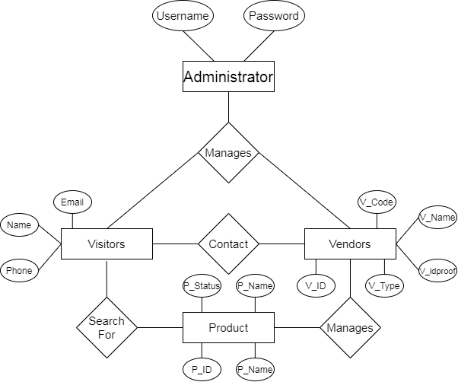

Figure 2 ER-Diagram: Entity relationship diagram

**4.2 Data-flow-diagram**

The Data Flow Diagram routes the flow of information for the system, by using the symbols like rectangle, circle, and arrows, short text labels to show the data flow routes between each destination.

The data flow diagrams are functionally divided into Zero level, First level, and Second level data flow diagrams.

1. **Zero level DFD**

**Registration Details Check-in**

**Administrative**

**Vendors**

**Users**

**Database**

**Main page**

**Check-out**

**Login Details Authentication**

Figure 3 Zero level data flow diagram

1. **One level DFD**

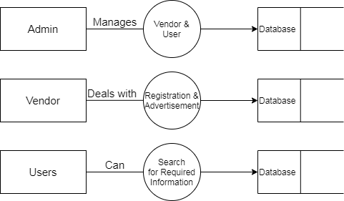

Figure 4 One level data flow diagram

1. **Two-level DFD**

* **Administrative two- level DFD**

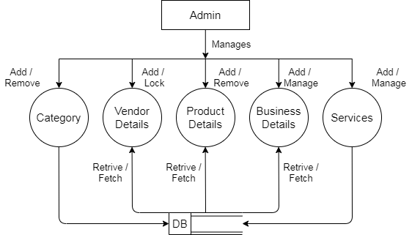

Figure 5 Administrative two-level data flow diagram

* **Vendors two-level DFD**

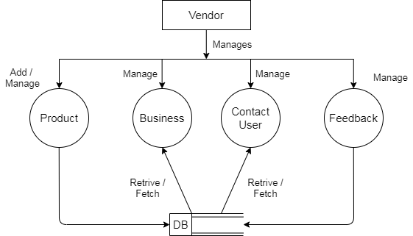

Figure 6 Two-level data flow diagram

* **Users two-level DFD**

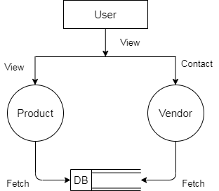

Figure 7 Two-level data flow diagram

**4.3 DATA DICTIONARY**

After carefully understanding the requirements of the client, the entire data storage requirements are divided into the below tables.

**TABLE I : b_Category**

Business Category (b_Category) table contains the list of businesses available for the vendors to categories the businesses.

|  |  |  |
| --- | --- | --- |
| **Fields** | **Type** | **Description** |
| c_id | int(100) | Primary key |
| c_name | varchar(100) |  |
| c_desc | varchar(255) |  |
| is_Active | int(10) |  |
| Created_dt | varchar(100) |  |

**TABLE II : b_details**

Business Details (b_details) table contains the detailed information of registered and verified business.

|  |  |  |
| --- | --- | --- |
| **Fields** | **Type** | **Description** |
| b_id | int(100) | Primary key |
| sc_id | int(100) | Foreign key |
| b_name | varchar(100) |  |
| b_desc | varchar(225) |  |
| b_estdate | varchar(100) |  |
| b_mobile | varchar(100) |  |
| b_email | varchar(100) |  |
| b_website | varchar(100) |  |
| b_address | varchar(100) |  |
| b_city | varchar(100) |  |
| created_dt | varchar(100) |  |

**TABLE III : b_photos**

Business Photos (b_photos) table contains the photos of the product or service description photos and cover photo for the business page.

|  |  |  |
| --- | --- | --- |
| **Fields** | **Type** | **Description** |
| bp_id | int(100) | Primary key |
| b_id | int(100) | Foreign key |
| Bp_photolink | varchar(100) |  |
| Bp_slider1 | varchar(100) |  |
| Bp_slider2 | varchar(100) |  |
| Bp_slider3 | varchar(100) |  |
| created_dt | varchar(100) |  |

**TABLE IV : b_subcat**

Business Sub-Category (b_subcat) table contains the Sub-category of the the Business available under particuler Category of the businesses.

|  |  |  |
| --- | --- | --- |
| **Fields** | **Type** | **Description** |
| sc_id | int(100) | Primary key |
| c_id | varchar(100) | Foreign key |
| sc_name | varchar(100) |  |
| sc_desc | varchar(100) |  |
| sc_icon | varchar(100) |  |
| is_Active | int(10) |  |
| created_dt | varchar(100) |  |

**TABLE V : contact_us**

Contact us (contact_us) table contains the information of the customer details requests for the enquire about the business or the services.

|  |  |  |
| --- | --- | --- |
| **Fields** | **Type** | **Description** |
| cs_id | int(100) | Primary key |
| b_id | int(100) | Foreign key |
| p_name | varchar(100) |  |
| p_desc | varchar(100) |  |
| p_photos | varchar(100) |  |
| created_dt | varchar(100) |  |

**TABLE VI : faq**

Frequently Aksed Question (faq) table contains the answers for the questions asked by the user and user can ask question.

|  |  |  |
| --- | --- | --- |
| **Fields** | **Type** | **Description** |
| id | int(100) | Primary key |
| faq_question | varchar(300) |  |
| faq_answer | varchar(1500) |  |
| created_dt | varchar(20) |  |
| last_updated | varchar(20) |  |
| Status | varchar(10) |  |

**TABLE VII : feedback_details**

Feedback Details (feedback_details) table contains the review of the product and services and user can provide feedback for the product or service and vendor can resolve the issue if any.

|  |  |  |
| --- | --- | --- |
| **Fields** | **Type** | **Description** |
| f_id | int(100) | Primary key |
| feedback_id | varchar(100) | Foreign key |
| fullname | varchar(100) |  |
| Email | varchar(100) |  |
| Phone | varchar(100) |  |
| Msg | varchar(100) |  |
| Status | varchar(20) |  |
| created_dt | varchar(100) |  |

**TABLE VIII : feedback_reply**

Feedback Reply (feedback_reply) table contains the reply provided by the vendor for the feedback asked by the user for the perticuler product or services.

|  |  |  |
| --- | --- | --- |
| **Fields** | **Type** | **Description** |
| feedback_id | varchar(100) | Primary key |
| Name | varchar(100) |  |
| Email | varchar(100) |  |
| Phone | varchar(100) |  |
| Msg | varchar(1000) |  |
| Status | varchar(20) |  |
| created_dt | varchar(100) |  |

**TABLE IX : lgn_tbl**

Login (lgn_tbl) table contains the list of verified users and vendors login creditions for accesing the D-Ads portal.

|  |  |  |
| --- | --- | --- |
| **Fields** | **Type** | **Description** |
| lgn_id | int(100) | Primary key |
| Username | varchar(100) |  |
| Password | varchar(100) |  |
| Email | varchar(100) |  |
| u_type | varchar(100) |  |
| s_ques | varchar(100) |  |
| s_ans | varchar(100) |  |
| u_status | varchar(100) |  |

**TABLE X : Login_info**

Login Information (Login_info) table contains the data of the users login activity for security purpose.

|  |  |  |
| --- | --- | --- |
| **Fields** | **Type** | **Description** |
| Id | int(10) | Primary key |
| Name | varchar(100) |  |
| Timestamp | varchar(100) |  |
| ip_address | varchar(100) |  |
| mac_address | varchar(100) |  |
| Status | varchar(50) |  |

**TABLE XI : OTP**

One Time Password (OTP) table contains the OTP for logging into the D-Ads Portal.

|  |  |  |
| --- | --- | --- |
| **Fields** | **Type** | **Description** |
| Id | int(10) | Primary key |
| Username | varchar(100) |  |
| Otp | int(10) |  |
| Status | varchar(50) |  |
| Timestamp | varchar(50) |  |
| Hashvalue | varchar(100) |  |

**TABLE XII : product_details**

Product Details (product_details) table contains list of product details associated with the businesses registered.

|  |  |  |
| --- | --- | --- |
| **Fields** | **Type** | **Description** |
| p_id | int(100) | Primary key |
| b_id | int(100) | Foreign key |
| p_name | varchar(100) |  |
| p_desc | varchar(100) |  |
| p_photos | varchar(100) |  |
| p_status | varchar(100) |  |
| created_dt | varchar(100) |  |

**TABLE XIII : vender_details**

Vender Details (vender_details) table contains the list of registered and verified venders.

|  |  |  |
| --- | --- | --- |
| **Fields** | **Type** | **Description** |
| v_id | int(100) | Primary key |
| v_name | varchar(100) |  |
| v_email | varchar(100) |  |
| v_mobile | varchar(100) |  |
| v_idproof | varchar(100) |  |
| v_photos | varchar(100) |  |
| v_reg_date | varchar(100) |  |
| v_status | int(10) |  |

**TABLE XIV : Vender_type**

Vender Type (Vender_type) table contains the types of the venders with their activated plan. Ex. Free , Basic , Premium.

|  |  |  |
| --- | --- | --- |
| **Fields** | **Type** | **Description** |
| v_id | int(10) | Primary key |
| v_type | varchar(100) |  |
| Vtype_desc | varchar(225) |  |
| Status | int(10) |  |

**4.4 Use case diagram**

* **Use case diagram**

**Administrative**

**User**

**Vendors**

Figure 8 System use case diagram

* **Administrative use case diagram**

**Administrative**

Figure 9 Administrative level use case diagram

* **Users use case diagram**

**Users**

Figure 10 Users level use case diagram

* **Vendors use case diagram**

**Vendors**

Figure 11 Vendors level use case diagram

**4.5 Activity diagram**

* **Registration page activity diagram**

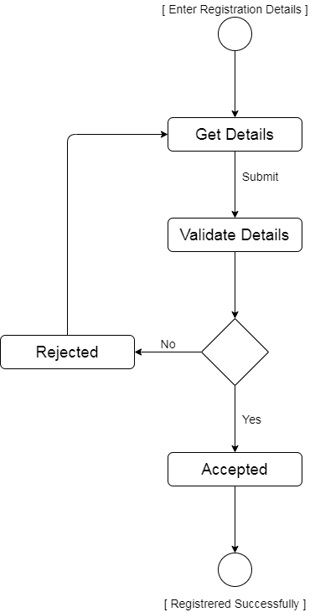

Figure 12 Registration page activity diagram

* **Login page activity diagram**

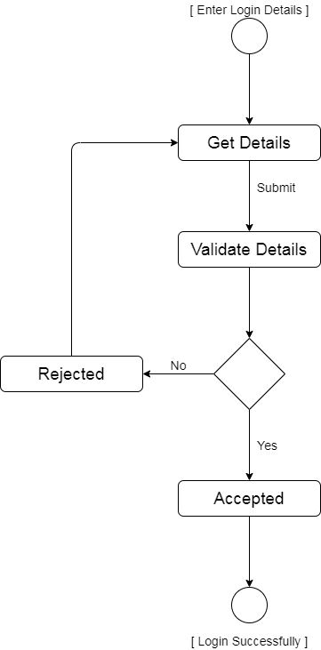

Figure 13 Login page activity diagram

* **Administrative activity diagram**

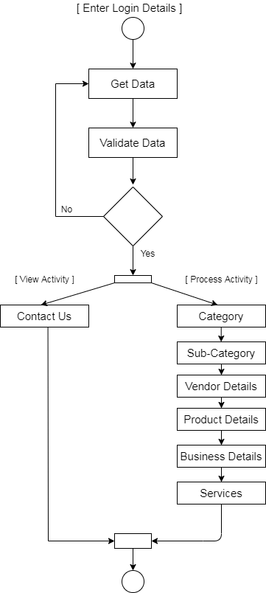

Figure 14 Administrative activity diagram

* **Vendors activity diagram**

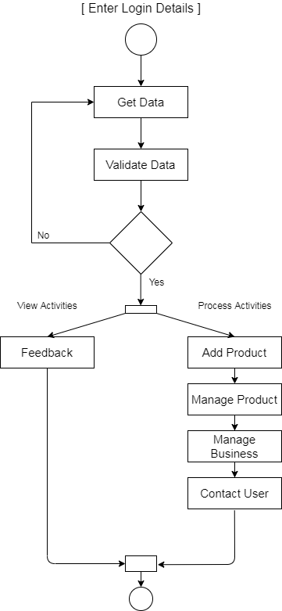

Figure 15 Vendors activity diagram

* **Users activity diagram**

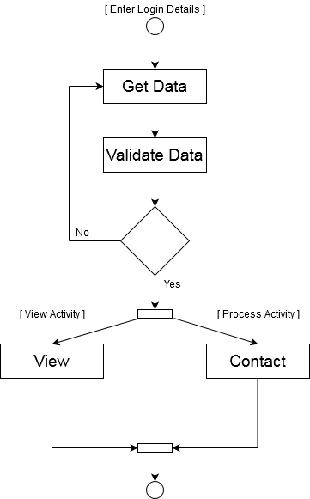

Figure 16 Users activity diagram

**4.6 Relational Schema**

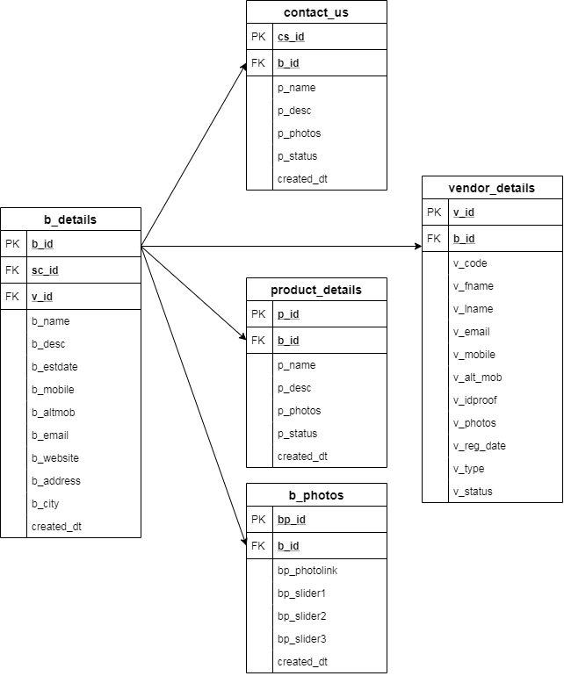

Figure 17 Relational Schema

**Chapter 5**

**VERIFICATION AND VALIDATION**

**5.1 Introduction**

The verification and validation can also be referred to as software quality control. It is the process of checking whether the software fulfills its purpose and meets all the requirements.

**5.2 Methodology used**

**Agile methodology**

While each of the agile mythologies is unique in its specific approach, they all share a shared vision and core values. They all fundamentally incorporate iterations and the continuous feedback that it provides to refine and deliver a software system successively. They all involve continuous planning, continuous testing, continuous integration, and other forms of the continuous evolution of software. They are lightweight, especially compared to traditional waterfall-style processes, and inherently adaptable. What is more critical about the agile method is that they all focus on empowering people to collaborate and make decisions together quickly and effectively.

* Test first programming
* Refactoring
* Continues iterations
* Simple design
* Coding standards

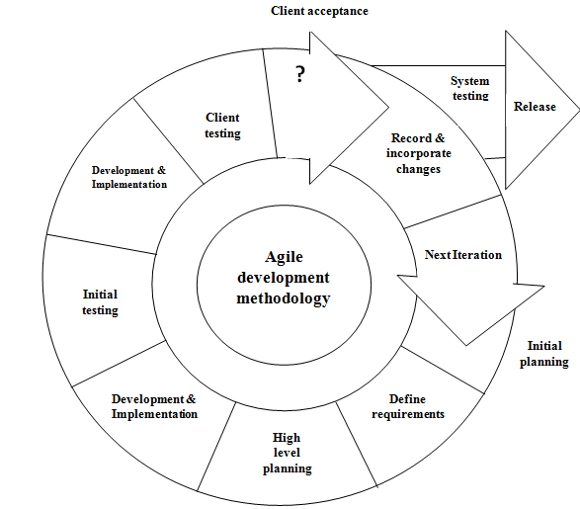

Figure 18 Agile model.

The scope of work is not defined up front soWe have used agile developmet approach to have agility and flexibility at the core of the entire development process. To find solutions for the evolving requirements through regular collaboration and communication. To Plan, analyze, design, develop, document, and test simultaneously and iteratively.

We have used agile model for web development by creating modules and integrating them per sprint. Then optimizing the site through several minor adjustments, rather than waiting for weeks and making major changes.

**5.3 Testing technology**

**Black Box Testing**

Black Box Testing is one of the approaches to the testing scenario, or we can call it the type of testing. In black-box testing will do the test engineers, where the framework functionality will be checked. The black box testing code will not visible to the test engineers. Here we are checking the missing function if any interface error, we will be checking the performance of the software and its behaviors. Here we also check any external error regarding the database access, etc.

**White Box Testing**

White Box Testing is also called as Code testing. This testing is done by the developer while developing the code for the software. This testing is concerned with the developer where the code will be visible to perform the testing, and this testing involves step by step procedure to perform the testing. In this testing, we check all the independent condition and also the path in the code, whether all the related path is executed at least once or not.

We also check whether the necessary loop and the condition were checked are not, here we are checking the boundaries of the possibilities for the logical condition or decision for the accurate and false .here we will check the data structure is valid or not.

Ensure whether the possible validity check and validity lookups have been provided validate data entry.

**Testing Strategies:**

**Levels of testing:**

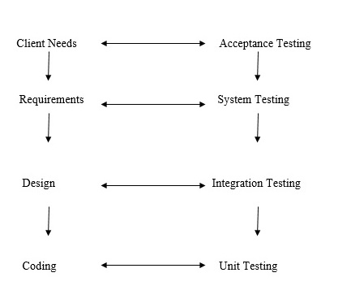

Figure 19 Levels of testing.

The different testing is carried out, which reflects its effectiveness and Efficiency of different phases of the software development where these tests help to uncover the error in the corresponding phase.

There are two general strategies for testing software mentioned above in the fig 19. The above mentioned stagies described below.

**Code Testing:**

Code Testing, where we will check the program logic, is correct or not. Todo this, we are using the test case, which is developed by the tester to check every path of the code logic as well as the flow of the program.

**Specification Testing:**

In this testing approach, we are using for the specification that is required to test the various behaviors of the application in various conditions. To perform the specification testing developer writes the test case with all the combinations of conditions to perform the specification testing.

**Integration Testing:**

Integration Testing is performed after the unit testing, where the testing can involve the integration, i.e., all the units which are done with the testing those will be combined, integrated with the other entire module, and performs the testing order to maintain the consistency.

**Chapter 6**

**IMPLEMENTATION RESULT**

1. **Home page**

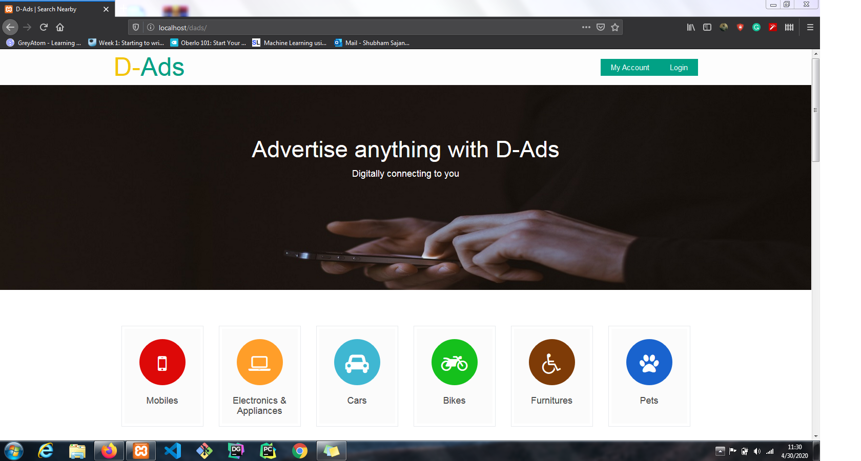

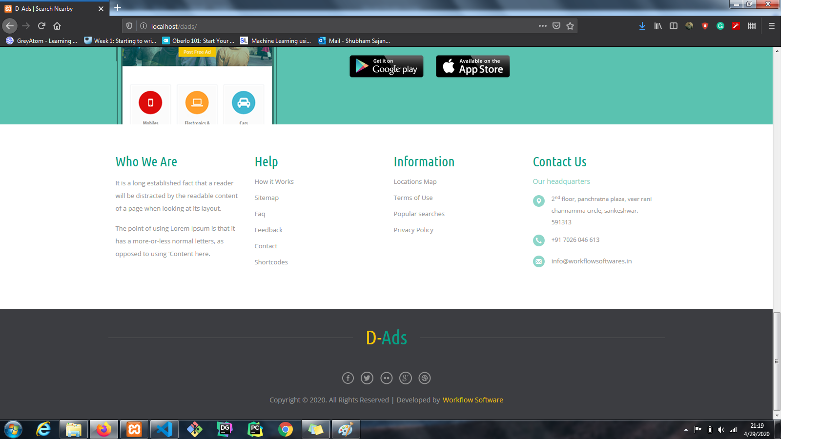

1. **Categories**

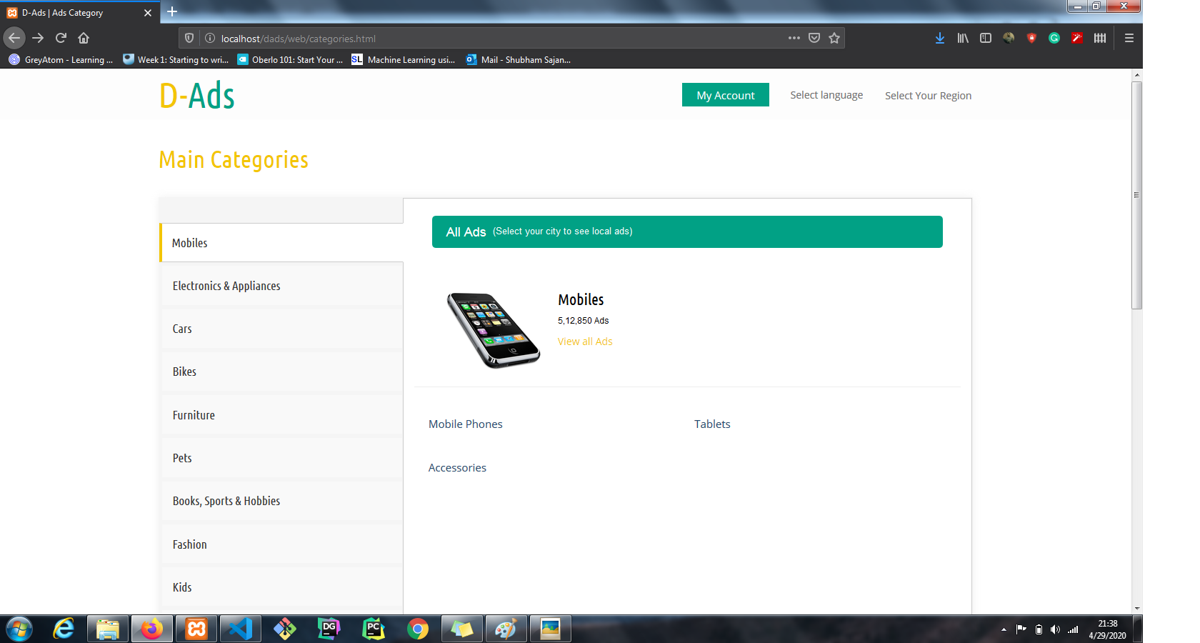

1. **Login**

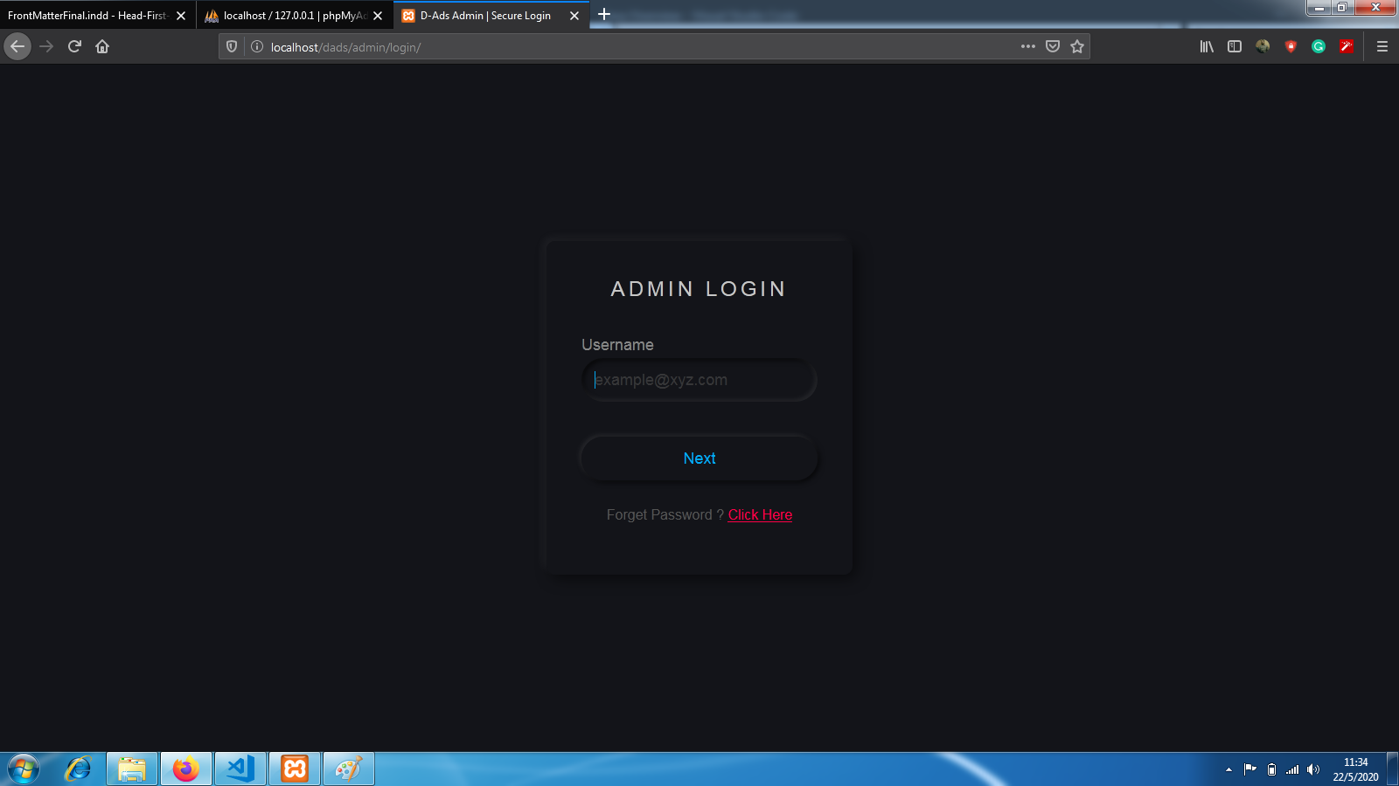

1. **Post Ads**

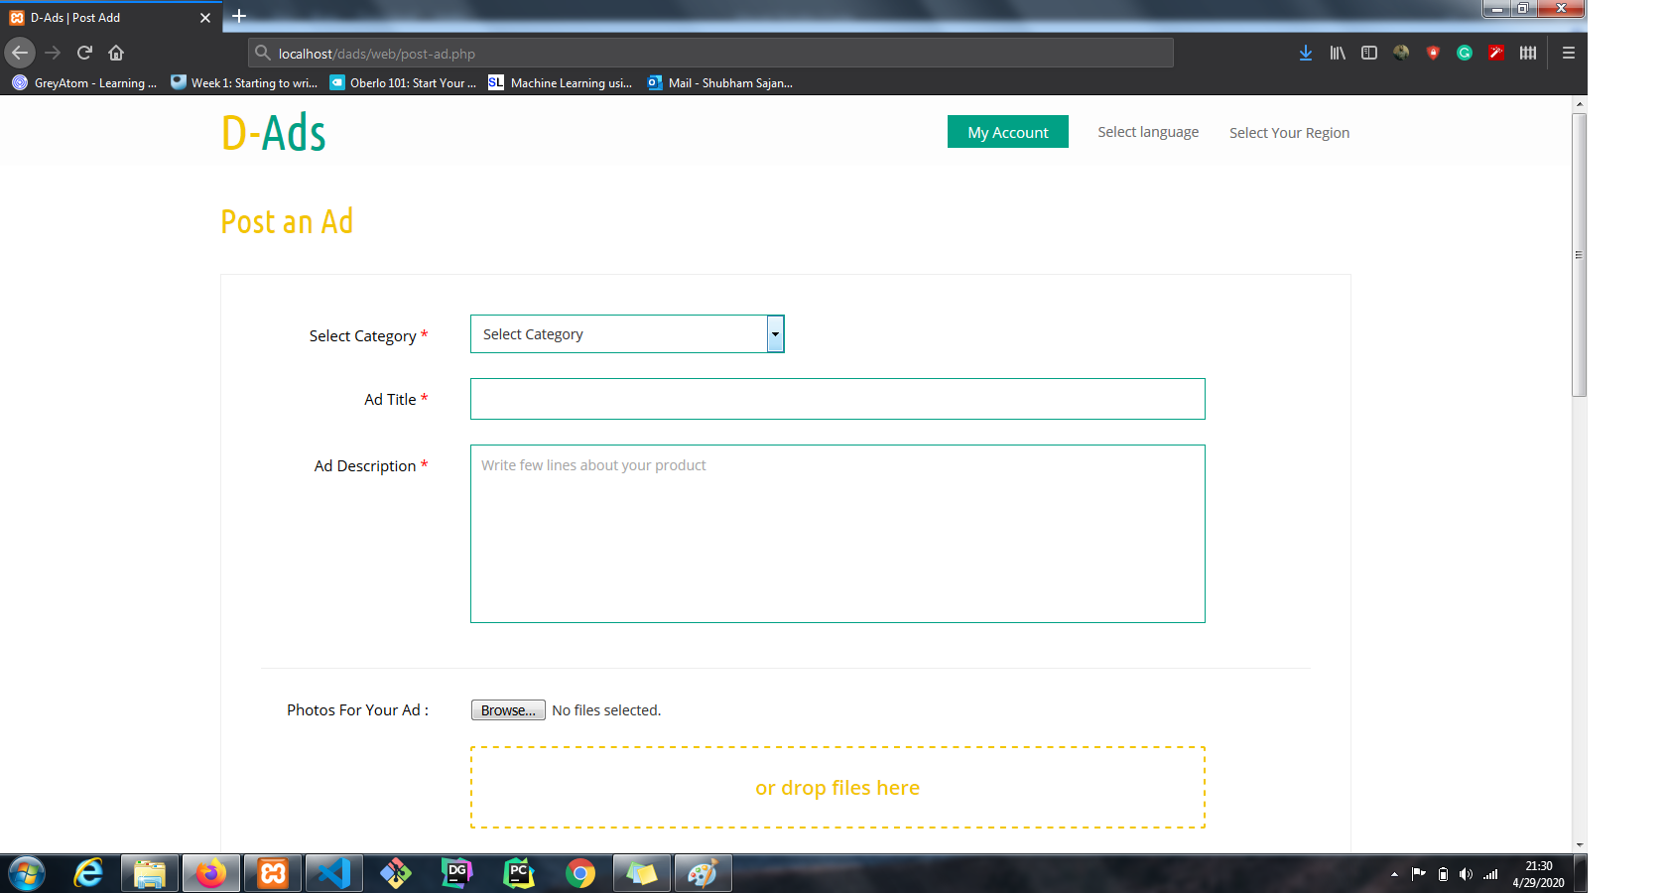

1. **Product Details**

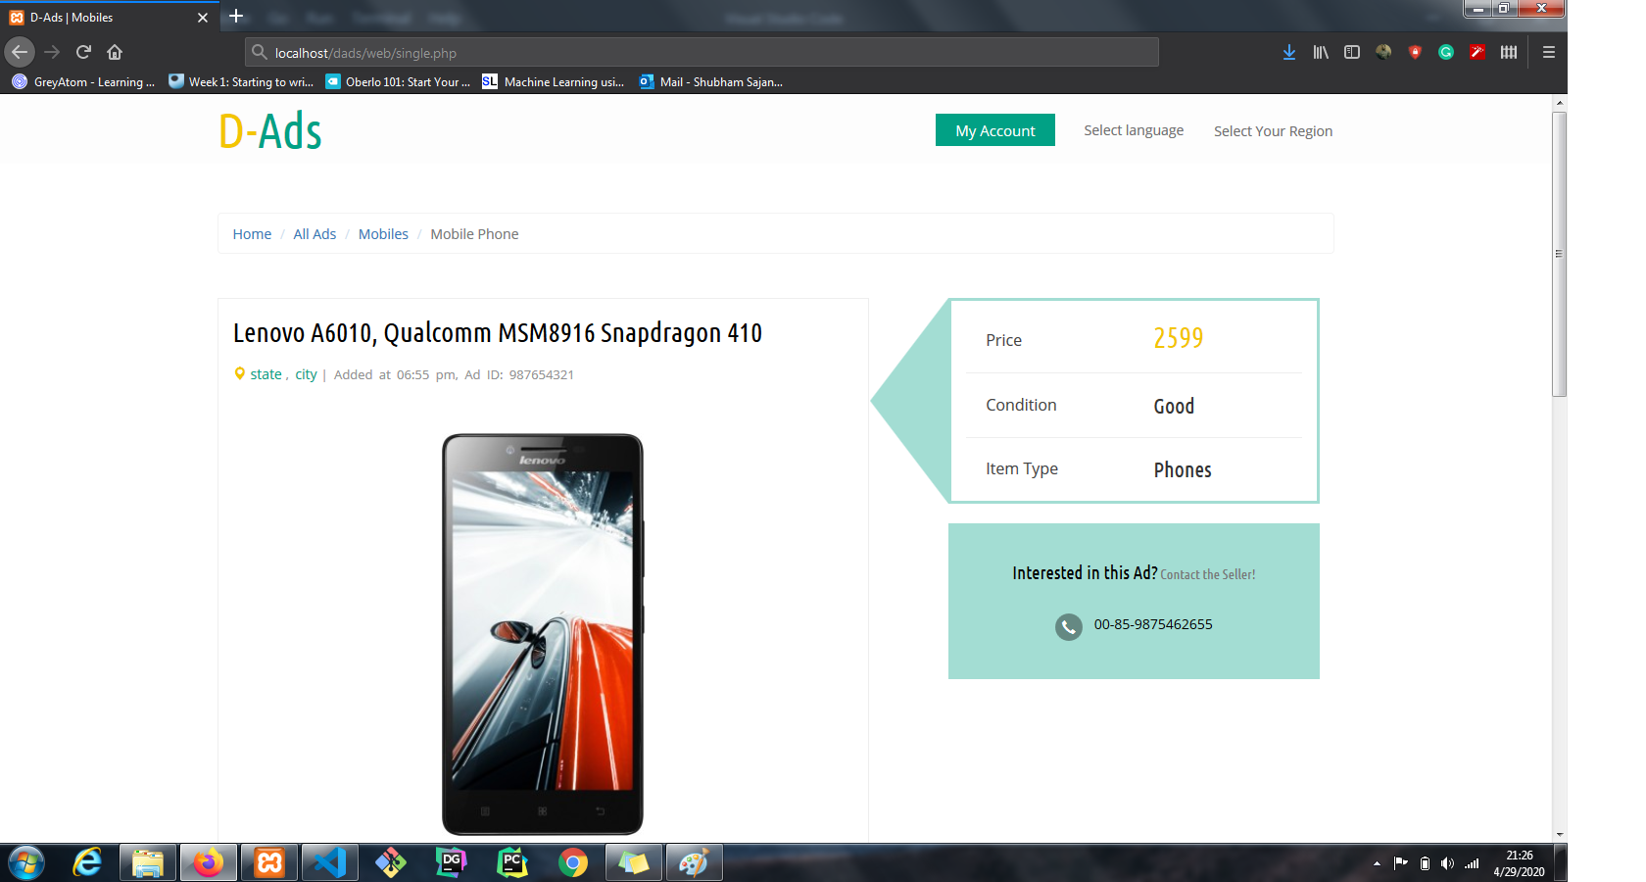

1. **Contact Us**

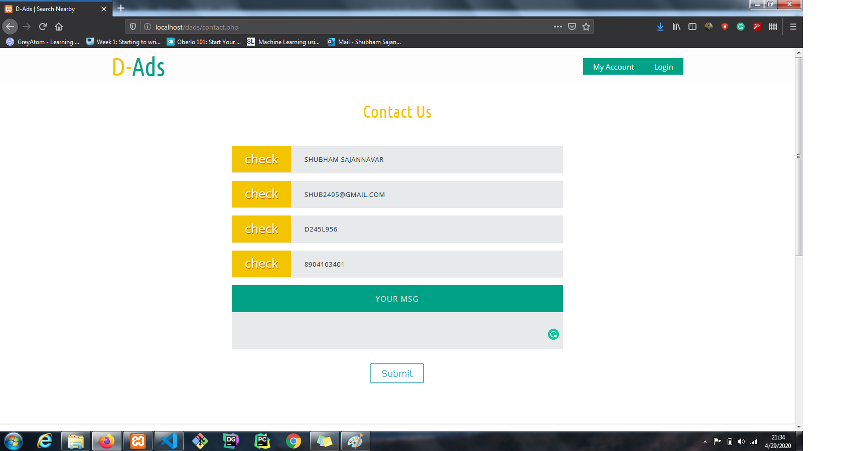

1. **Admin Home**

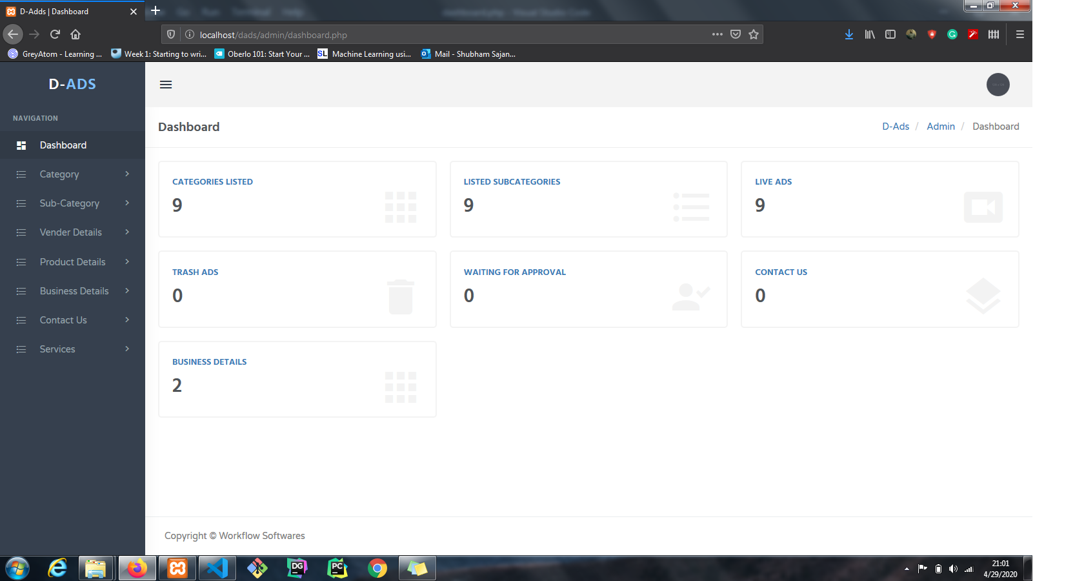

1. **Admin Add Product**

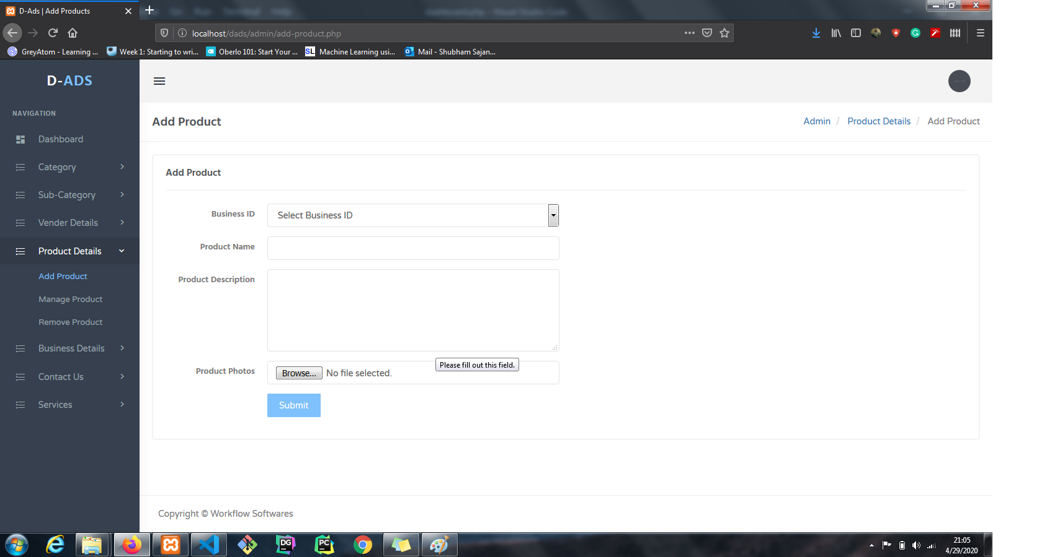

1. **Admin Add Vendor**

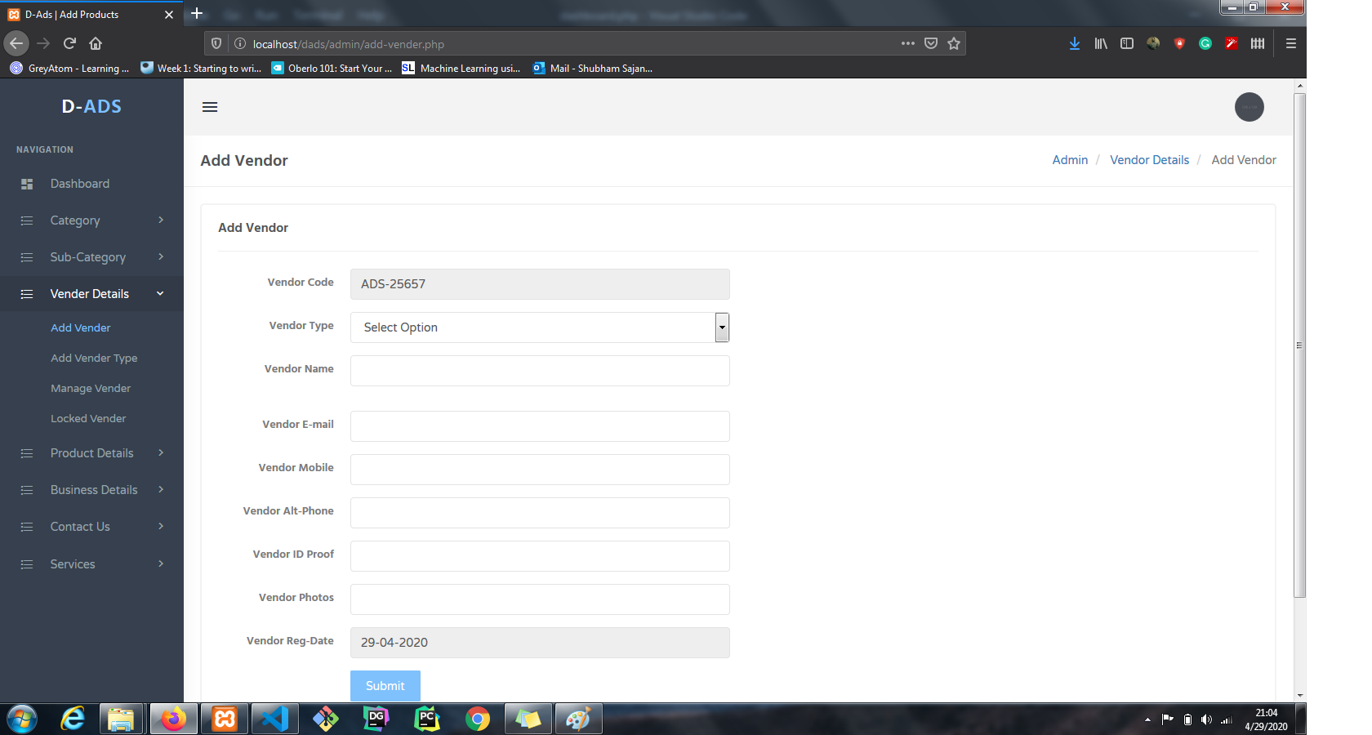

1. **Admin Add Business**

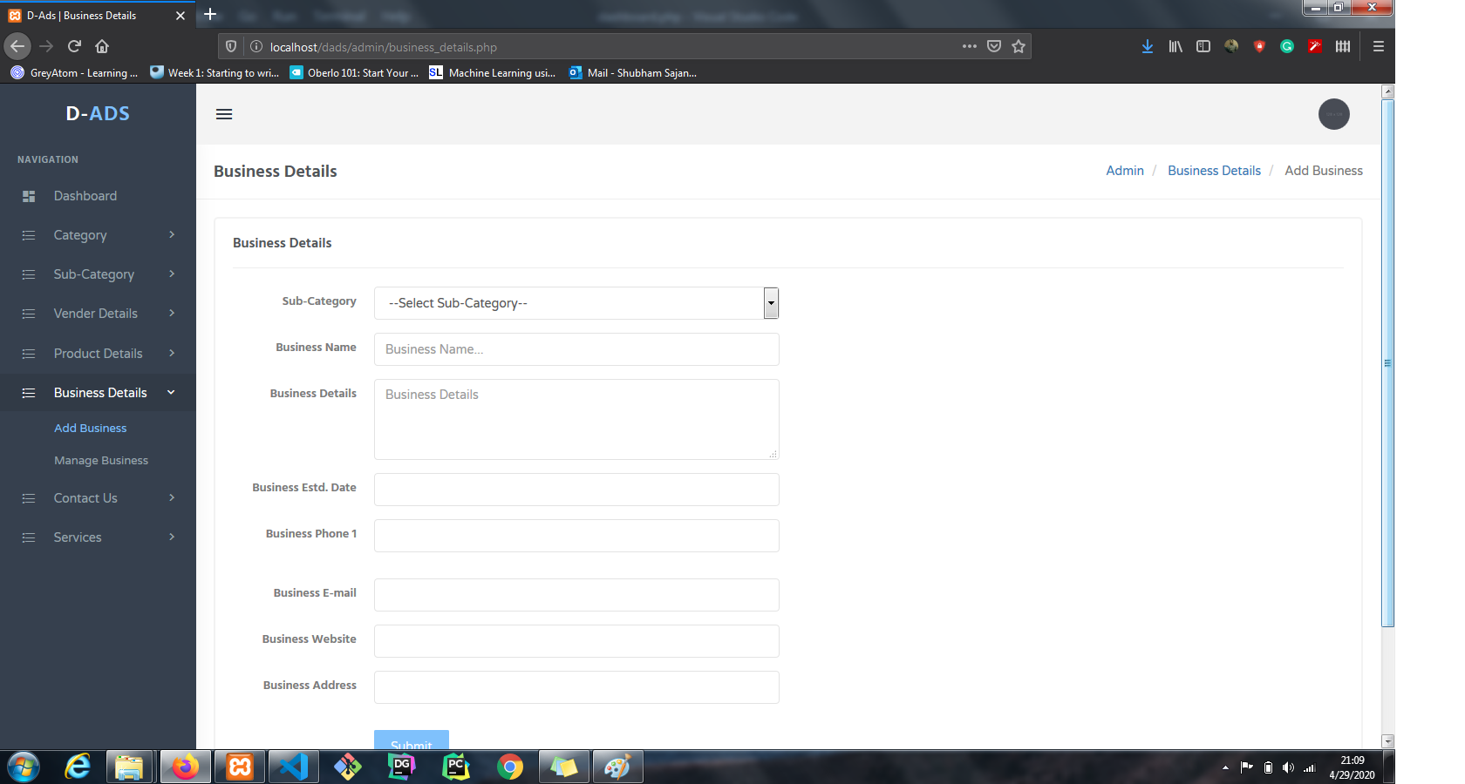

1. **Changes Password**

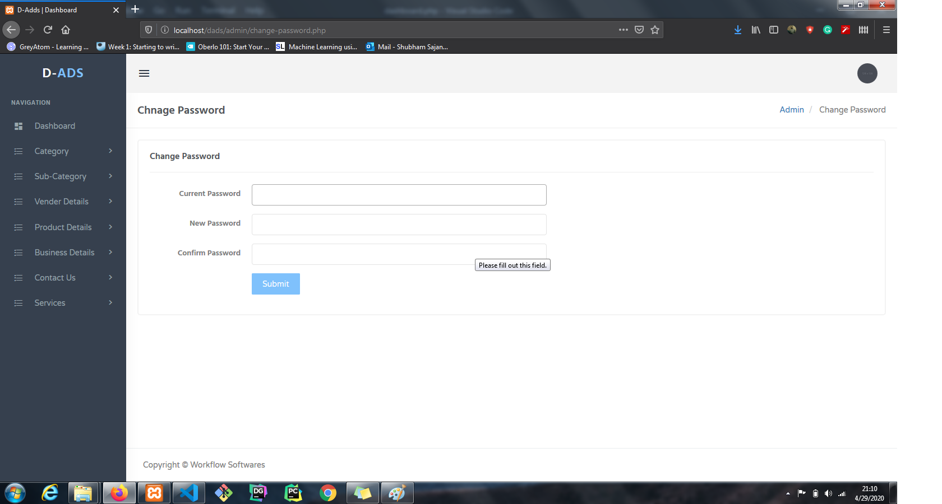

**Chapter 7**

**CONCLUSION AND FUTURE SCOPE**

This D-Ads application is developed for the necessity of the users to get all the nearby product and service information at one click. Using this application makes it easy to locate and find detailed information about a particular Product/Service. D-Ads is the Local Search Engine that provides comprehensive updated information of all the Business to Business and Business to customer products and services. This application is also used to help the buyers to display advertising of their product/services on the platform and sellers to get in touch with each other.

The main moto of the future enhancement is to subjoin additional features and update the application in the future to make the application more efficient for providing better user service to the users.

Some future functions are:

* Customize according to local demands.
* Target a smaller area and then expand.
* Vendor Panel can be customizable according to the plan.
* Digital marketing of Products/Services across various social networking platforms.
* Use/Visitor can have a panel to discuss the issue or access the functionality of the system to get the things done.
* The payment gateway integrations.
* The discussion forum and communication portal will enable.

**REFERENCES**

1. A Silberschatz, H Korth, S Sudarshan, Database System and Concepts, fifth Edition McGrawHill.
2. Paul C. Jorgensen: Software Testing, A Craftsman’s Approach, 3rd Edition, Auerbach Publications, 2012.
3. Sommerville, Software Engineering, 8/e, Pearson Education.
4. Pressman S. Roger, Software Engineering, Tata McGraw Hill.
5. PHP for the Web: Visual Quick Start Guide, 4th Edition, Peachpit Press.
6. Thomas Powell, Web Design The complete Reference, Tata McGrawHill.
7. Beginning PHP 5.3 (Wrox, free ebook: http://it-ebooks.info/book/713/).
8. Janice Reynolds, The Complete E-Commerce Book: Design, Build & Maintain a Successful Webbased Business, CRC Press.
9. https://www.scribd.com/doc/97174264/Project-Report-on-just-dial.
10. https://www.justdial.com/
11. https://en.wikipedia.org/wiki/Justdial